Flutter Plugin Android Studio Installation Documentation

**Step 1:** Open Android Studio and select ‘configure’.

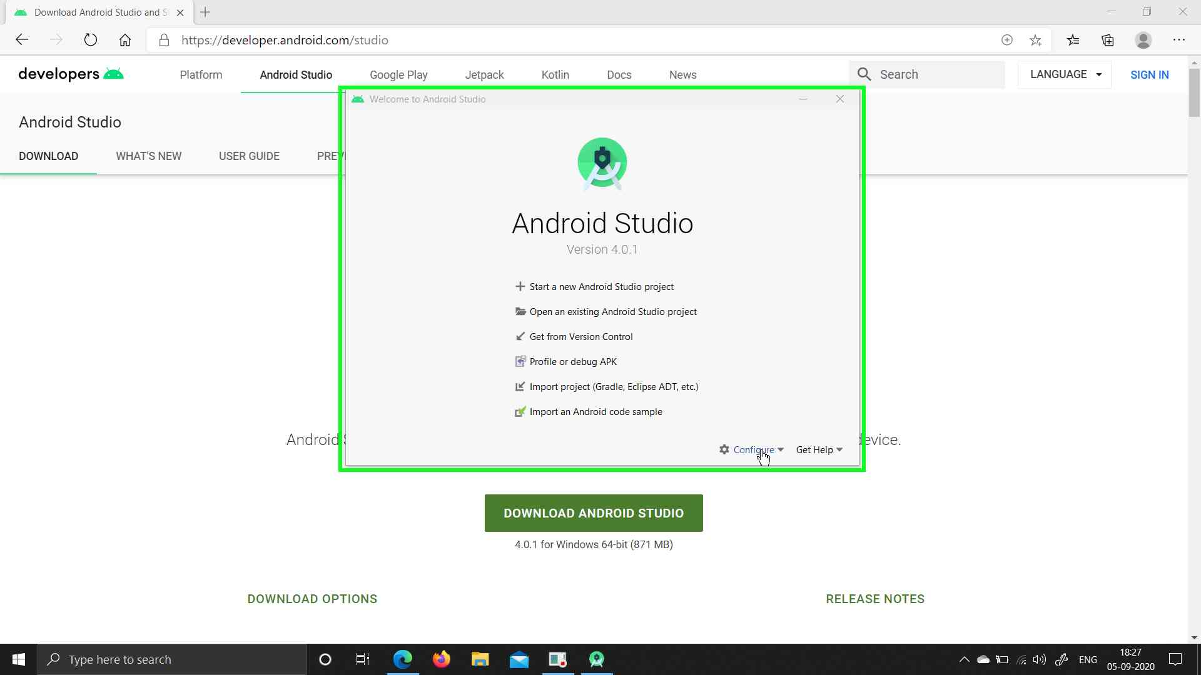

**Step 2:** Select SDK Manager

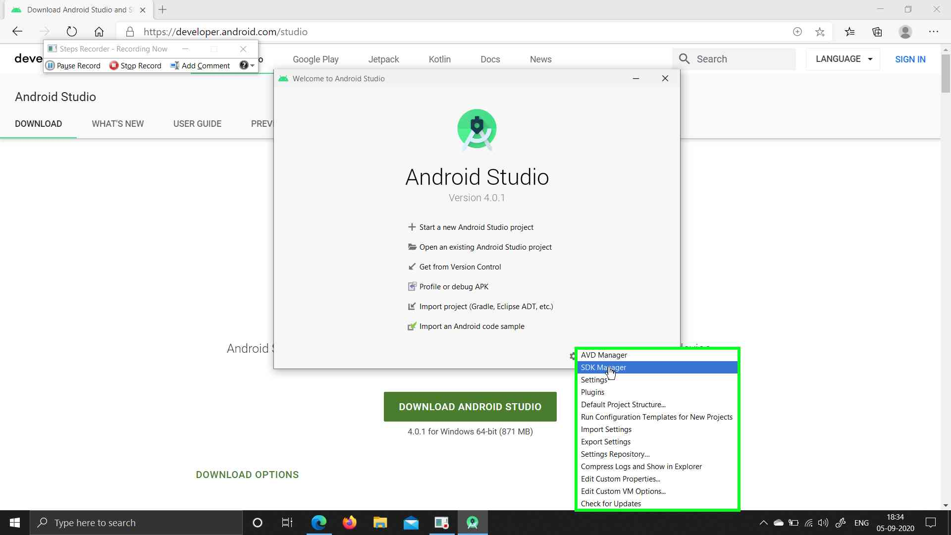

**Step 3:** Select ‘Plugins’

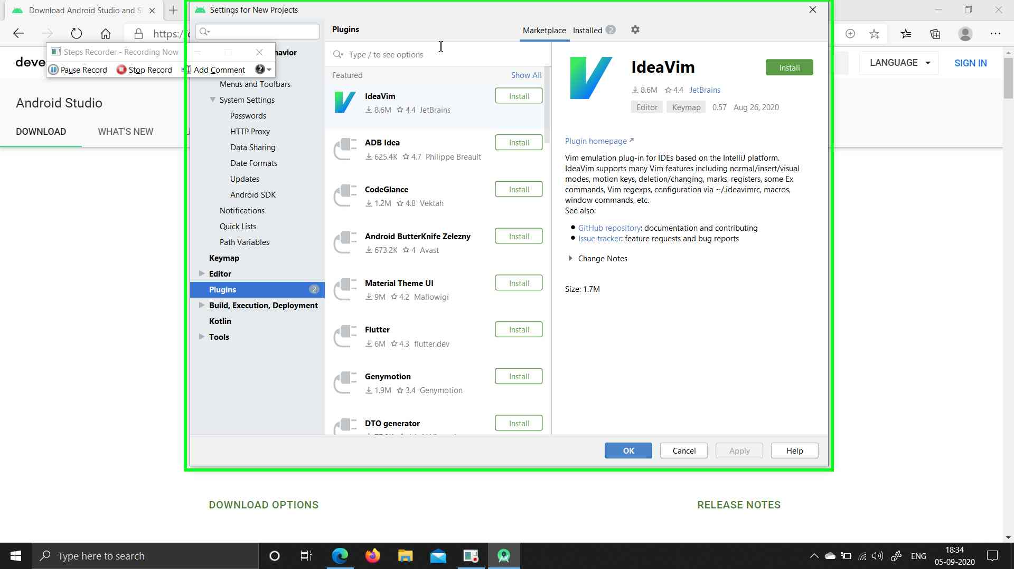

**Step 4:** Search for flutter in search bar and then click on Install

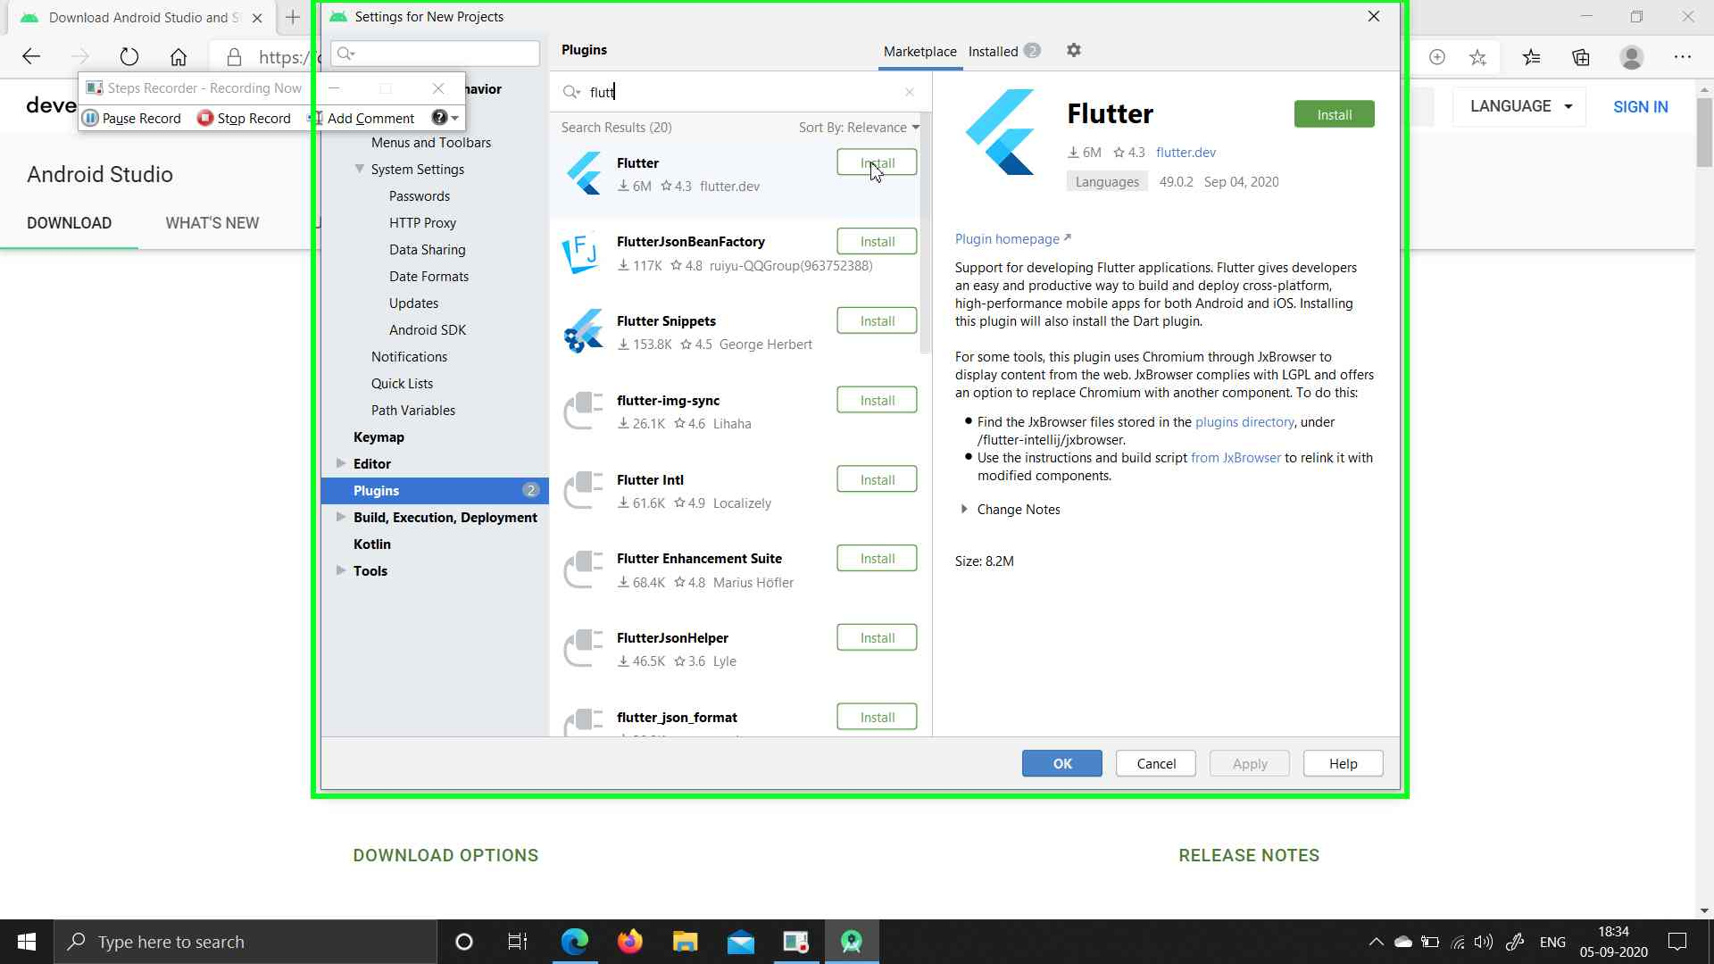

**Step 5:** Click ‘Accept’ in alert.

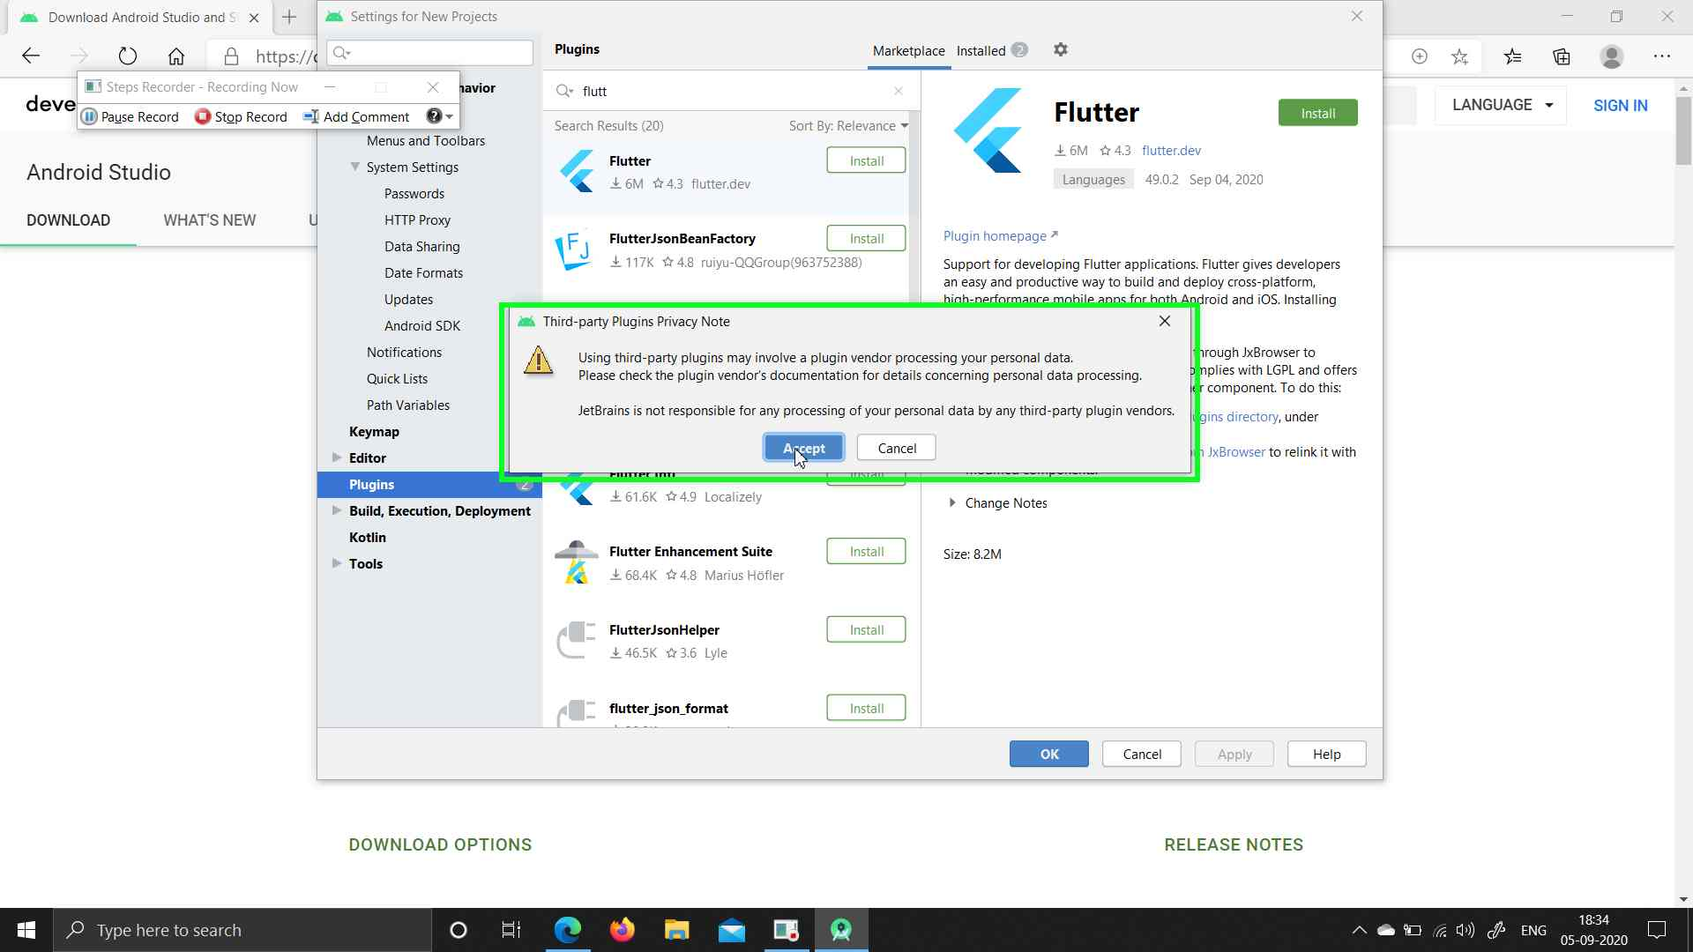

**Step 6:** Click ‘Install’ in alert

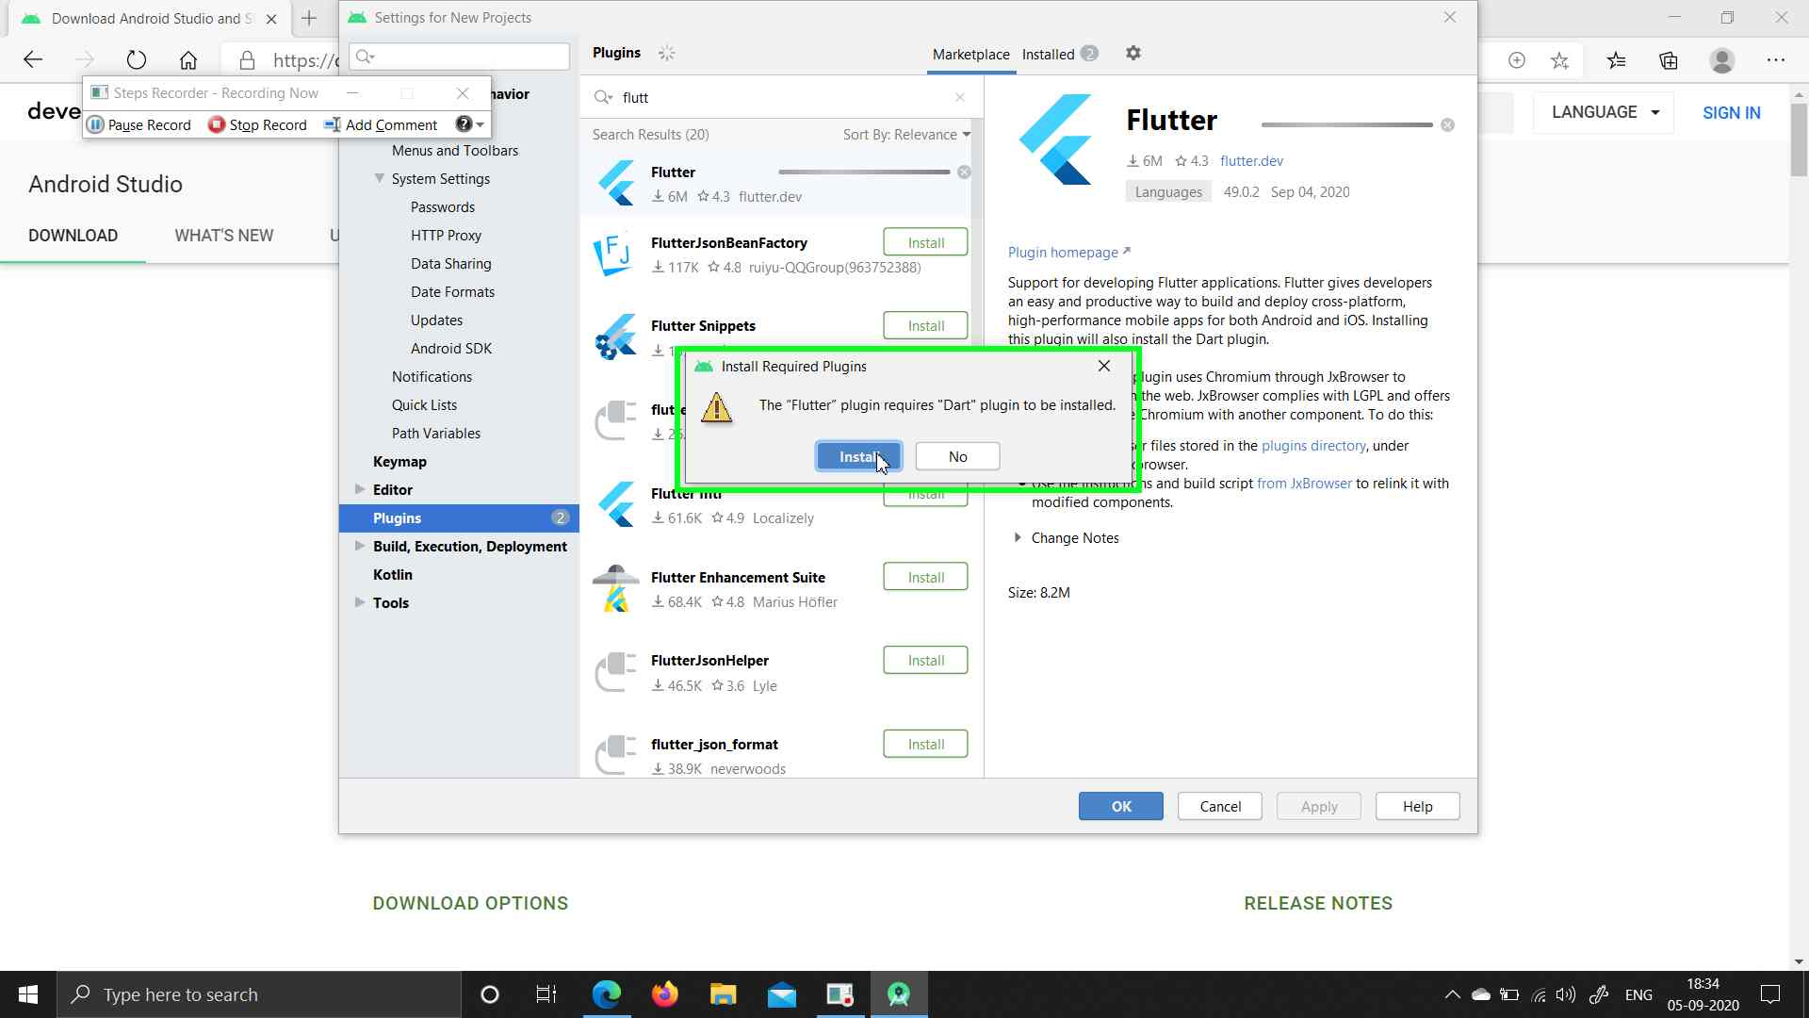

**Step 7:** Select ‘Restart IDE’

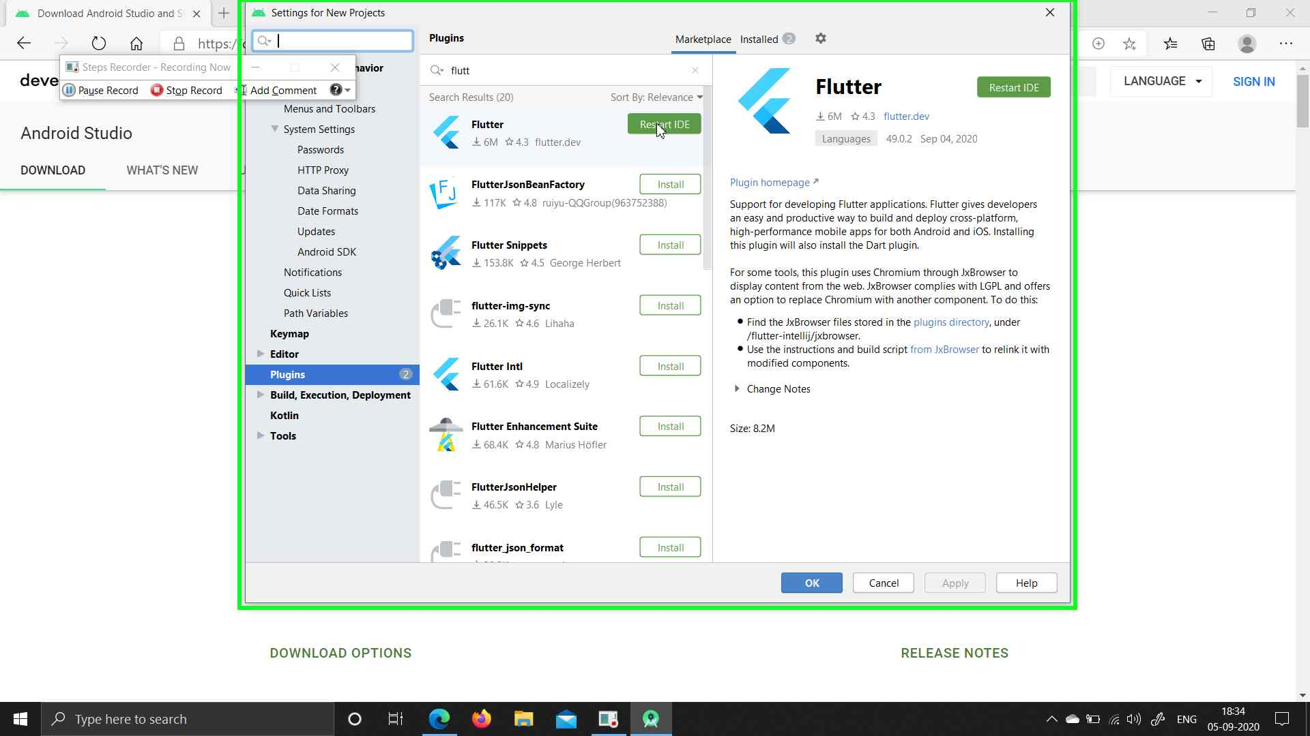

**Step 8:** Click ‘Restart’ in alert.

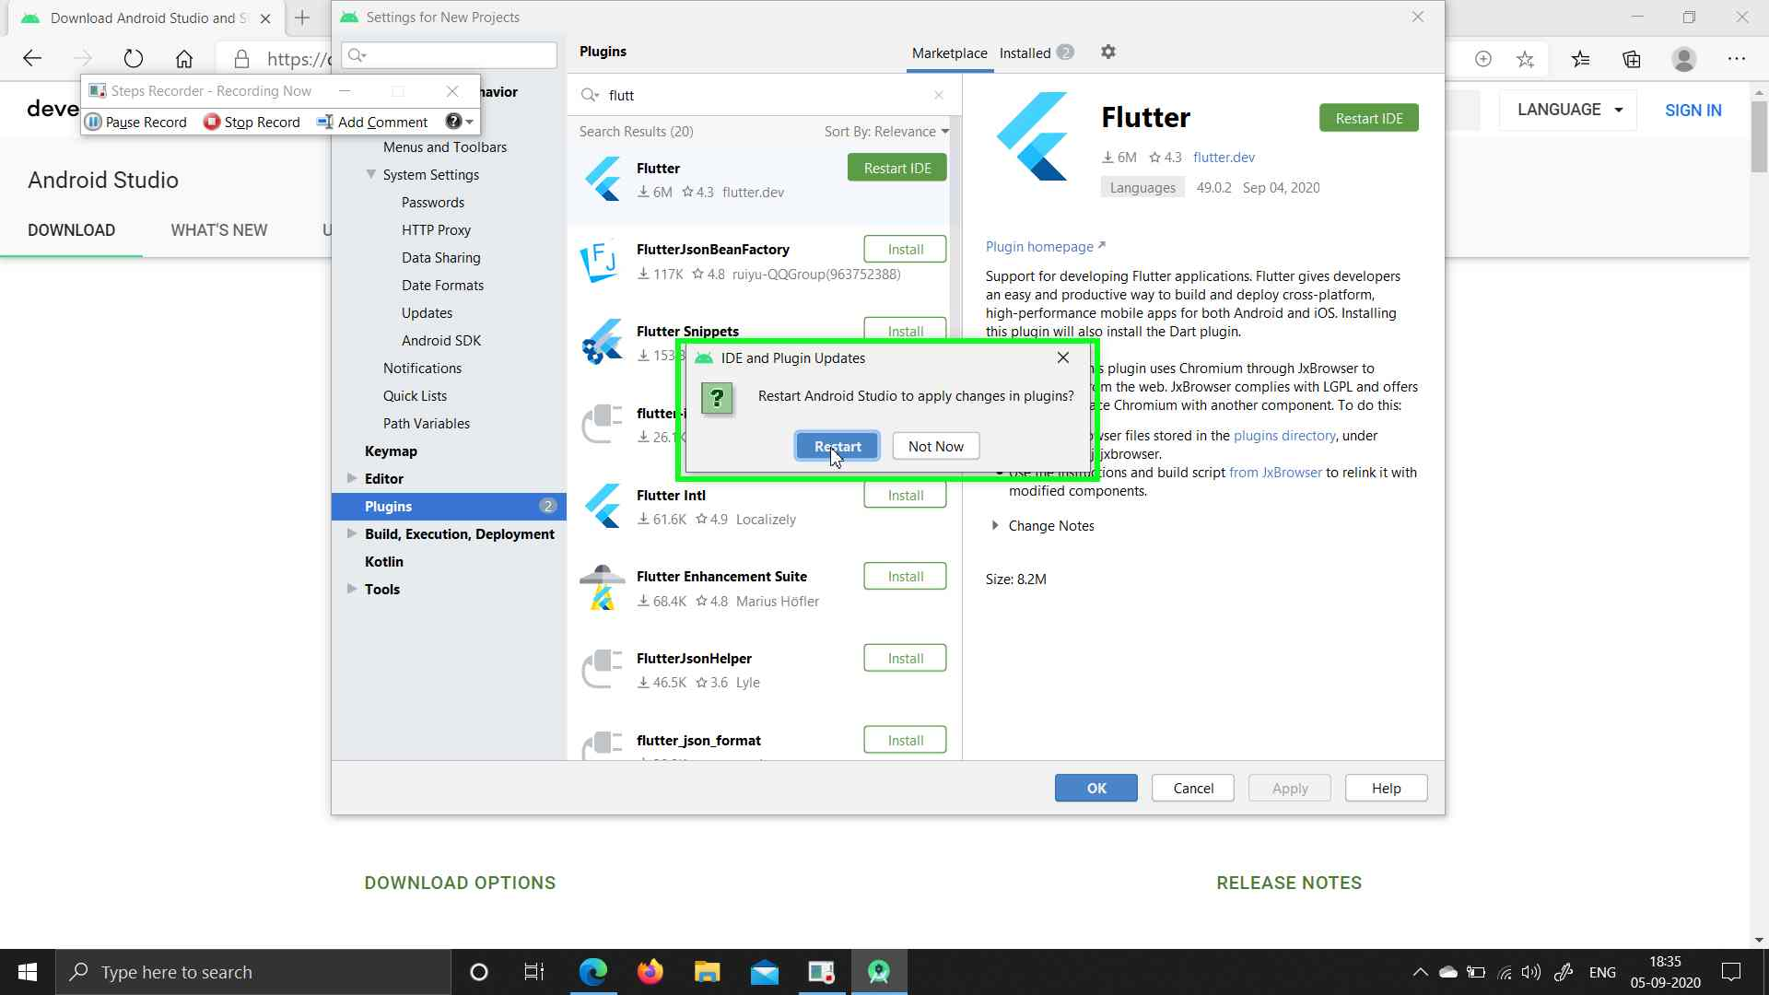

Next

**Step 9:** Flutter Plugin Installed

